Checklist for Document Remediation
General Formatting
1 | Keep the paragraph marker on – (found in the main toolbar)
2 | Ensure every page uses Times New Roman font in 12 pt size. (for normal text).
3 | Verify the content in the Word document matches the PDF, including spellings, Bold, Italics [Line by line checking is needed]
4 | Use Lightshot or a snipping tool to capture screenshots from the PDF.  Tips: Zoom in before taking the screenshot to ensure better clarity.
5 | All images should be center-aligned and inline with text; Image caption should be center aligned  Use Auto Insert Caption option for figure Names.
6 | Add page numbers at the start of the page – top left corner (not at the end).
7 | Insert a page break in the Word document at the end of each PDF page.
8 | Eliminate extra spaces and sentence breaks to maintain proper structure.
9 | Give bullets and numberings as per the pdf  - Evaluation, answer the question, choose the correct answers also under the numbering  - before numbering all the lines properly left aligned and use indent numbering for sub points
10 | Recreate the table if format is not proper, no merged cells involved, instead repeat the words
11 | Write abbreviations meaningfully for screen reader users  Example: Keep "UNESCO" as is, but write "US" as "U S" , “AB” as “A B”for better accessibility.
12 | The sentences should not be incomplete at the end of the page. Complete the sentence by taking it from next page.
Rules to follow for Equation Box
1 | remove extra spaces in the equation
2 | separate the equation if multiple equation inside the equation
3 | use sin, tan, cos, sin⁻¹ etc from the equation tool. Do not type manually.
4 | keep the equation number outside the equation
5 | Any text connecting the equation should not be in the equation box
6 | All equation should look exact same as pdf like superscripts and subscript
7 | Simple equations should be outside the equation box

Heading Level
Heading | Font | Size,Style,Color
Level 1 (Book Name) | Times New Roman | 16, Black, Bold
Level 2 e.g UNIT 6 - RAY OPTICS | Times New Roman | 14, Black, Bold
Level 3 e.g, 6.1 – INTRODUCTION, summary, evaluation[ use hyphen as shown in example] | Times New Roman | 12, Black, Bold
Level 4 e.g, .6.1.1 - | Times New Roman | 12, Black, Bold
Level 5 | Times New Roman | 12, Black, Bold
Page no: heading level 6 | Times New Roman | 12, Black, Bold
Note: Heading level should be in hierarchy order
Proper spacing between the punctuations
1 | After a comma (, ): Add a space
2 | Before a comma (, ): Do not add a space.
3 | Before an open bracket ( ( ): Add a space.
4 | After an open bracket ( ( ):add a space.
5 | After a close bracket ( ) ): Add a space.
6 | Before and after a hyphen (-): Add spaces
Final Formatting
For all the heading , normal, text(basically for all the styles)
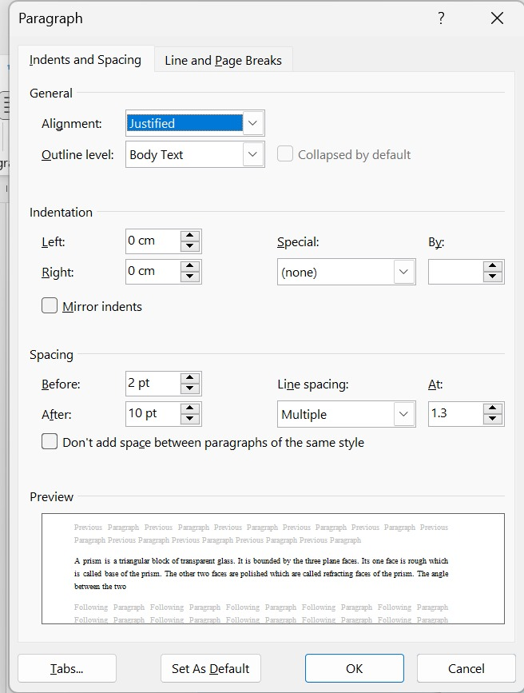
- Adding Alt text for all images, In alt text box, symbols does not read.
- Equation numbering should be right aligned, bookmarking and cross reference
- Ensure proper indented numbering for all exercises and answers
- Before the kg or units leave the space
- Heading level should be hierarchical order
Once Done with your remediation, Goto info->Check for accessibility and fix all the errors.
Created macros to generate alt text for all the images in the word document using groq.
- Code saved as .bas file, we can use the code by importing the module to the word document under normal

